**Content**

1. LA 2

1. Data stores 2

2. Networking 2

3. Security 2

4. Migrations 2

5. Architecting to scale 2

6. Business continuity 2

7. Deployments and operations 2

8. Cost Management 2

1. LA
   1. Data stores

Ephemeral: Data that is generally local to a resource and is lost when that resource is powered down. – Instance Store, ElastiCache

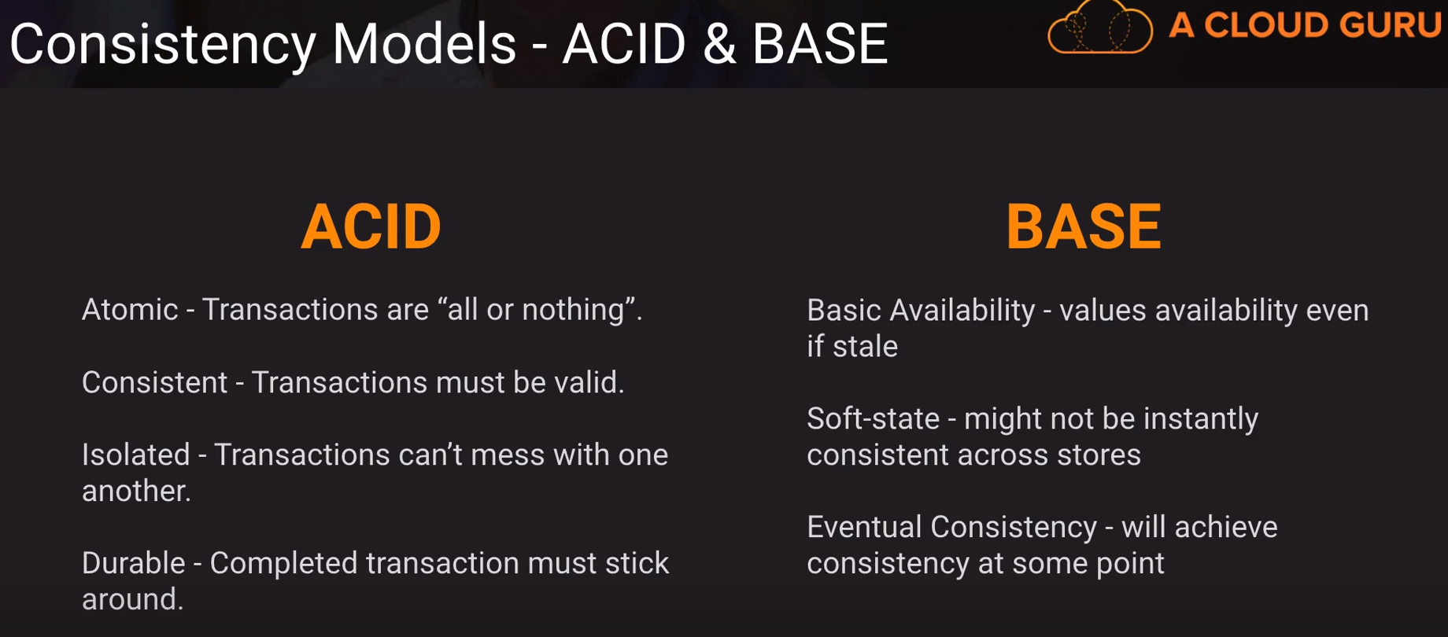

BASE Consistency model scales better.

* 1. Networking
  2. Security
  3. Migrations
  4. Architecting to scale
  5. Business continuity
  6. Deployments and operations
  7. Cost Management